CPE301 – SPRING 2019

MIDTERM 1

Student Name: Geovanni Portillo

Student #: 8000603824

Student Email: portig1@gmail.com

Primary Github address: <https://github.com/portig1/submissions_E>

Directory: portig1/submissions_E/tree/master/Midterms/Midterm_1

Submit the following for all Labs:

1. In the document, for each task submit the modified or included code (only) with highlights and justifications of the modifications. Also, include the comments.
2. Use the previously create a Github repository with a random name (no CPE/301, Lastname, Firstname). Place all labs under the root folder ESD301/Midterm, sub-folder named LABXX, with one document and one video link file for each lab, place modified asm/c files named as LabXX-TYY.asm/c.
3. If multiple asm/c files or other libraries are used, create a folder LabXX-TYY and place these files inside the folder.
4. The folder should have a) Word document (see template), b) source code file(s) and other include files, c) text file with youtube video links (see template).

1. **COMPONENTS LIST AND CONNECTION BLOCK DIAGRAM w/ PINS**

Atmel Studio 7

ATmega328PB Xplained mini

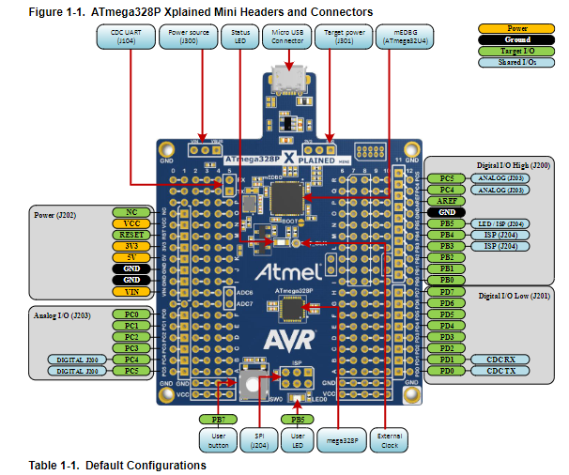

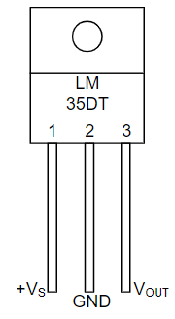

LM35 Schematic

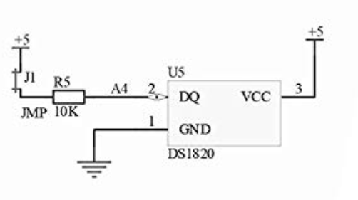

Arduino Shield U5 Schematic

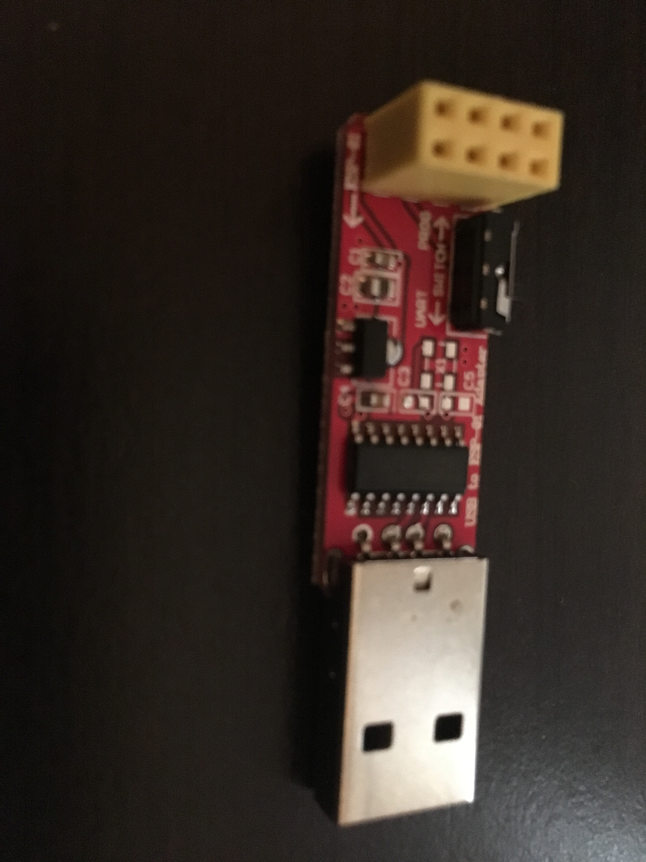

ESP-01 to USB Programmer/Adapter

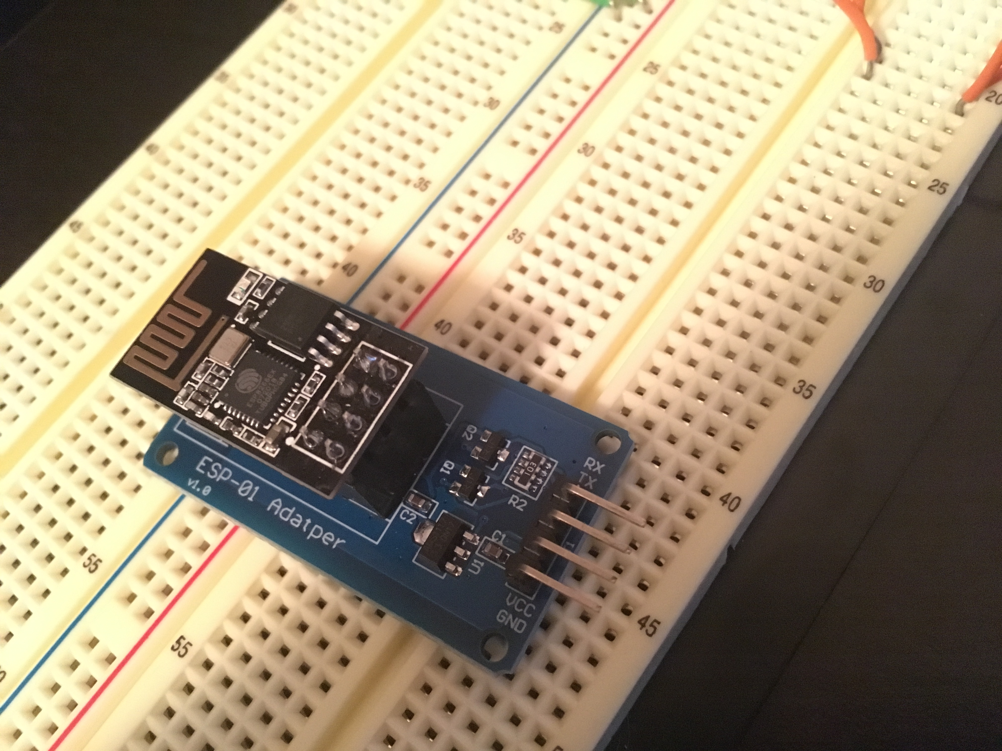

ESP-01 Adapter with ESP8266 plugged in

1. **DEVELOPED CODE OF TASK 1/2/5/6**

/*

Currently I've been able to send 12 temperature values to the ThingSpeak channel through the board setup. When I used a USB adapter for the ESP-01 module to

and ran the command sequence to send test values I was only able to send 4 values and I was repeatedly sending commands till it happened to work. Screenshots of

ESPlorer tests are included in the documentation document

*/

#define *F_CPU* 16000000UL

#define BAUD_RATE 115200 //BAUD RATE for ESP01 Module

#define BAUD_PRESCALLER (((*F_CPU* / (BAUD_RATE * 16UL))) - 1) //Gets ignored as the value for UBRR0 at 115200 BAUD RATE is floating point and the error rate was too high

#include <avr/io.h>

#include <avr/interrupt.h>

#include <stdio.h>

#include <util/delay.h>

void usart_init ();

void USART_send(unsigned char data);

void USART_putstring(char* StringPtr);

int main (void)

{

usart_init ();

sei();

TIMSK1 = (1 << OCIE1A);

OCR1A = 62499; //Using TCNT = clk*delay/prescaler - 1 to find OCR1A given clk = 16MHz, OCR1A was calculated to 62,499

TCCR1A = 0; // COM1A/B Normal Operation, OC1A/B Disconnected

TCCR1B = (1 << WGM12) | (1 << CS12); //WGM CTC Mode, Prescaler = 256

/** Setup and enable ADC **/

ADMUX = (0<<REFS1)| // Reference Selection Bits

(1<<REFS0)| // AVcc - external cap at AREF

(0<<ADLAR)| // ADC Left Adjust Result

(1<<MUX2)| // Analog Channel Selection Bits

(0<<MUX1)| // ADC4 (PC4 PIN27)

(0<<MUX0);

ADCSRA = (1<<ADEN)| // ADC Enable

(0<<ADSC)| // ADC Start Conversion

(0<<ADATE)| // ADC Auto Trigger Enable

(0<<ADIF)| // ADC Interrupt Flag

(0<<ADIE)| // ADC Interrupt Enable

(1<<ADPS2)| // ADC Prescaler Select Bits

(0<<ADPS1)|

(1<<ADPS0);

while (1)

{

}

return 0;

}

ISR(TIMER1_COMPA_vect)

{

ADCSRA|=(1<<ADSC); //start conversion

while((ADCSRA&(1<<ADIF))==0);//wait for conversion to finish

ADCSRA |= (1<<ADIF);

char thingSpeakUpdate[100];

int tempC = ADCL;

tempC = tempC | (ADCH<<8);

tempC = (tempC/1024.0) * 5000/10; //finish properly formatting tempC value

char setMUX[] = "AT+CIPMUX=0\r\n"; //Repeating the steps ESPlorer used

USART_putstring(setMUX);

*_delay_ms*(1000);

char thingSpeakStart[] = "AT+CIPSTART=\"TCP\",\"api.thingspeak.com\",80\r\n" ;

USART_putstring(thingSpeakStart);

*_delay_ms*(1000); //add in delay to allow for proper interactions

char thingSpeakSend[] = "AT+CIPSEND=80\r\n"; //saying we'll send more data than we actually will

USART_putstring(thingSpeakSend);

*_delay_ms*(1000);

*snprintf*(thingSpeakUpdate, sizeof(thingSpeakUpdate), "GET https://api.thingspeak.com/update?api_key=7FLJALZVSJK0QDM8&field1=%d\r\n", tempC);

USART_putstring(thingSpeakUpdate);

*_delay_ms*(1000);

char thingSpeakClose[] = "AT+CIPCLOSE\r\n";

USART_putstring(thingSpeakClose);

*_delay_ms*(1000);

}

void usart_init (void)

{

//UBRR0H = (uint8_t)(BAUD_PRESCALLER >> 8);

//UBRR0L = (uint8_t)(BAUD_PRESCALLER);

UBRR0 = 8; //Manually setting as the formula give a float value that has too much error.

//UCSR0A = (1 << U2X0);

UCSR0B = (1 << RXEN0) | (1 << TXEN0);

UCSR0C = (1<< UCSZ01)|(1<<UCSZ00);

}

void USART_send( unsigned char data) {

while (!(UCSR0A & (1 << UDRE0))); //wait until UDR0 is empty

UDR0 = data; //transmit ch

}

void USART_putstring(char* StringPtr) {

while (*StringPtr != 0x00) {

USART_send(*StringPtr);

StringPtr++;

}

}

1. **SCHEMATICS**

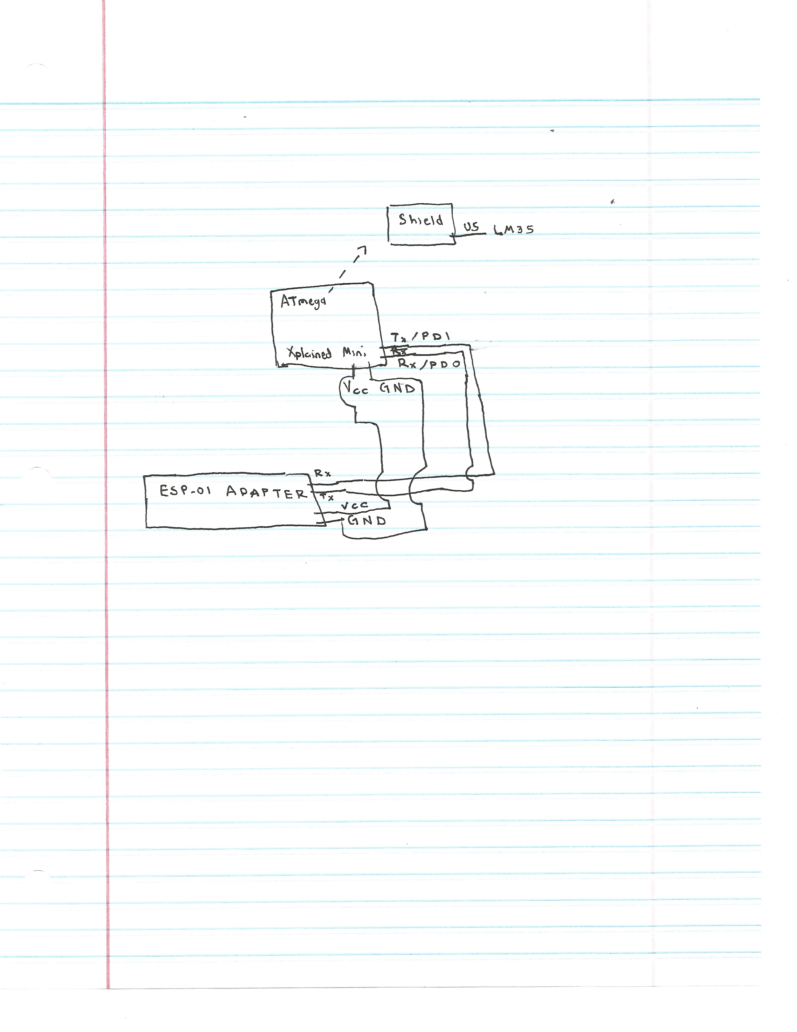

1. **SCREENSHOTS OF EACH TASK OUTPUT (ATMEL STUDIO OUTPUT)**

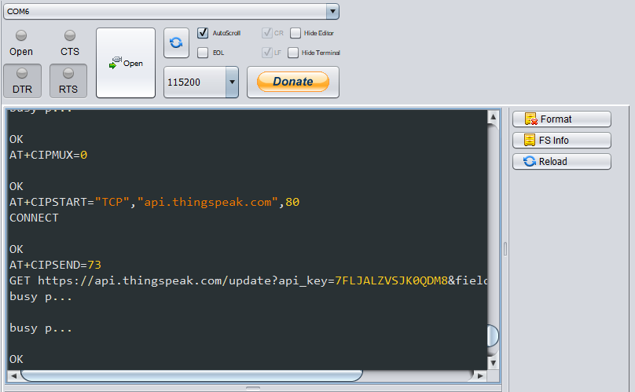

Output from ESPlorer tests, command sequence starts with “AT+CIPMUX”. I would often get a “busy p…” response when trying to use the send and GET command

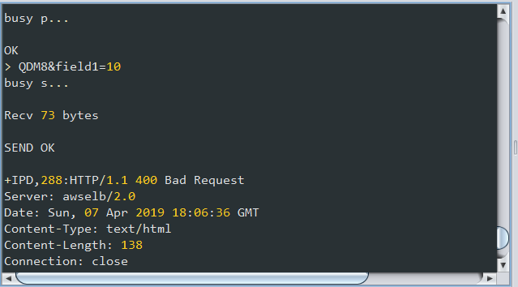

Trying to enter another start, send, or get command would lead to getting the “Bad Request” response

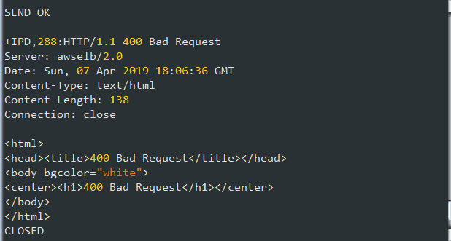

More of the “Bad Request” response

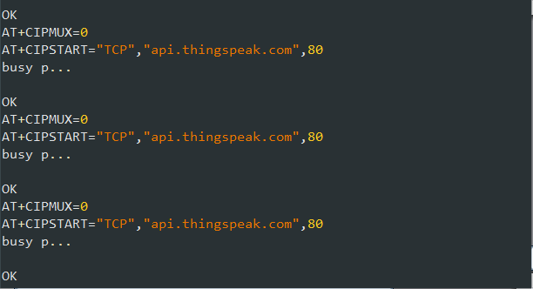

Example of the start command getting “busy p…” responses

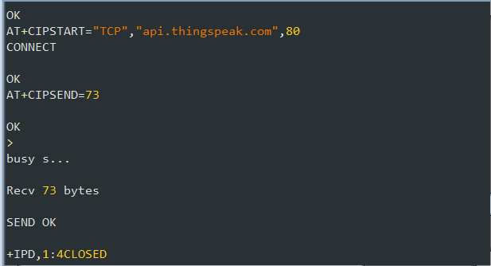

Example of one of the command sequences being processed successfully

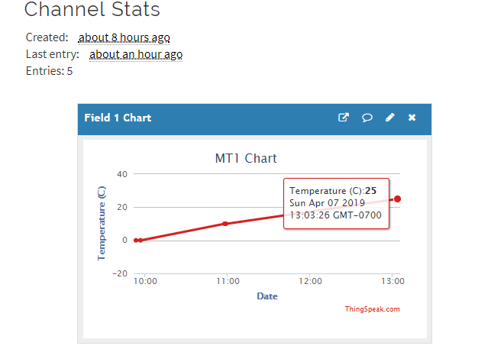

Screenshot from 4/7 at 2:23pm of data points. The first 4 values were done testing the ESP-01 module with a USB adapter and ESPlorer to see if I could send values. It was consistently failing to send data and only did so after repeatedly sending the sequence of commands.

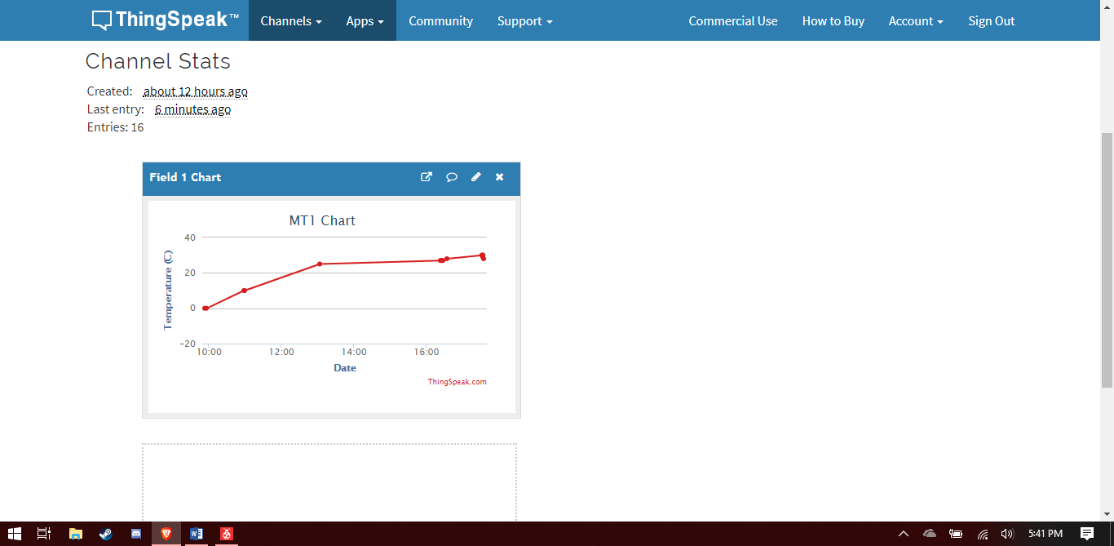

Screenshot on 4/7 at 5:41pm, the setup on the board was sending data, though inconsistently, having sent about 6 an hour prior to recording the video demonstration then another 5 during.

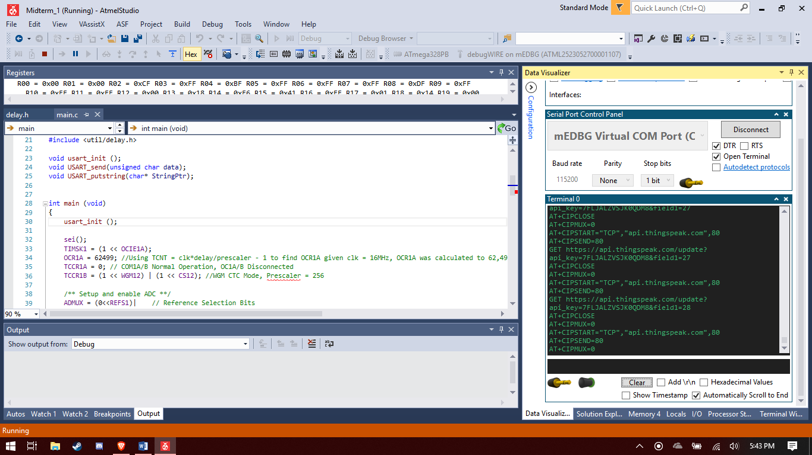

Screen capture of the serial output at a 115200 BAUDRATE showing the command sequence being sent to the ESP-01 module.

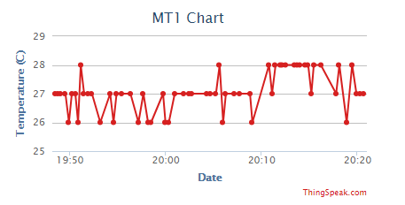

After changing the write key, the board was sending data every minute or so and after letting it run for a while it wrote a good amount of values.

1. **SCREENSHOT OF EACH DEMO (BOARD SETUP)**

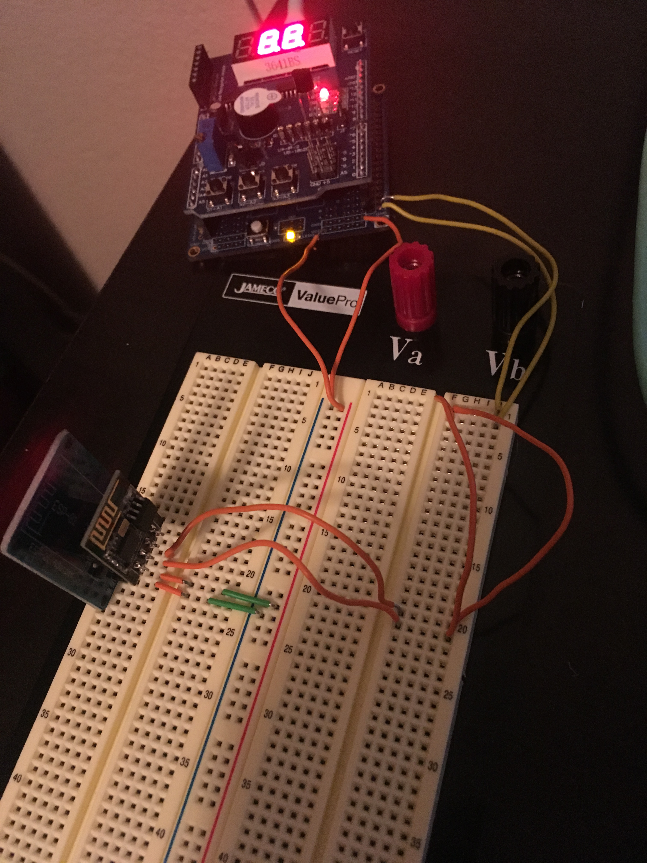

Board Setup, ESP8266 is plugged into ESP01-Adapter which is then connected to VCC and GND on Xplained mini while the TX line from the adapter is connected to RX (PD1) on the Xplained mini and then RX from the adapter to TX of the mini. The Arduino shield is connected on top with the LM35 in U5 of the shield.

1. **VIDEO LINKS OF EACH DEMO**

<https://youtu.be/LP-ESWnX6zo>

1. **GITHUB LINK OF THIS DA**

<https://github.com/portig1/submissions_E/tree/master/Midterms/Midterm_1>

**Student Academic Misconduct Policy**

<http://studentconduct.unlv.edu/misconduct/policy.html>

“This assignment submission is my own, original work”.

Geovanni Portillo